TITLE OF THE MANUSCRIPT (Times New Roman, 16 pt., bold, center, all caps)

Academic rank, Scientific degree, Author’s Full Name (Times New Roman, 16 pt., bold, center, if there are co-authors every author should be on a new row with the same formatting attributes and own footnote for email and institution)

Abstract: abstract up to 500 characters (Times New Roman, 12 pt., italic, justify)

Key words: between 4 and 6 words (Times New Roman, 12 pt., italic, justify)

JEL: JEL codes (Times New Roman, 12 pt., bold, justify)

- Introduction (Times New Roman, 14 pt., bold, left)
Body text that represents the introduction to the topic of the manuscript (Times New Roman, 14 pt., justify).

- Title of the first paragraph (Times New Roman, 14 pt., bold, left)
Body of the first paragraph (Times New Roman, 14 pt., justify).
Graphs, charts and pictures should be inserted with the option Wrap Text – In Line with Text. Titles of that objects are written below them preceded by the number of the figure (Figure 1, Figure 2, etc.). A source should be added below the title of the figure.

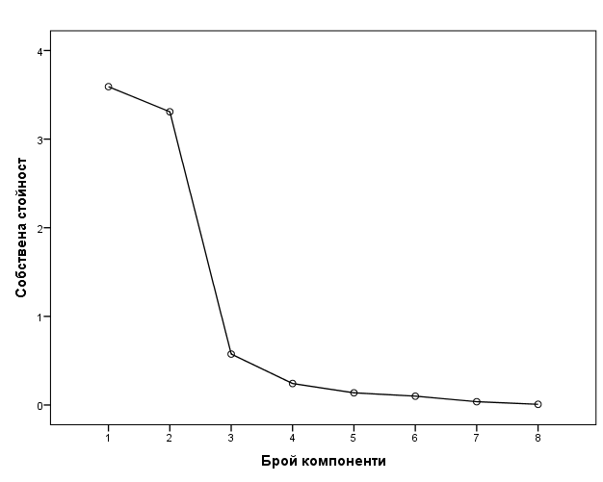
Figure 1. Title of the figure (Times New Roman, 14 pt., italic, center)
Source: www.nsi.bg (Times New Roman, 12 pt., italic, center)

References to other publications should be in APA citation style (https://libguides.willamette.edu/c.php?g=56954&p=367144). Any notes and comments should be placed in footnotes.

  - Title of the first subparagraph (Times New Roman, 14 pt., italic, left)
Body of the first subparagraph (Times New Roman, 14 pt., justify).
Tables should be numbered sequentially (Table 1, Table 2, etc.) and should have a title. A source should be added below the table.

Table 1. Title of the table (Times New Roman, 14 pt., italic, left)
Type | 2017 | 2018
Limited liability companies and joint stock companies | 1898 | 1974
Partnerships | 33 | 59
Source: NSI (Times New Roman, 12 pt., italic, left)

Data in the table should be formatted with Times New Roman font, 12 pt. A table should be centered against the text in the paragraph/subparagraph.

  - Title of the second subparagraph (Times New Roman, 14 pt., italic, left)
Body of the second subparagraph (Times New Roman, 14 pt., justify).
The number of paragraphs and subparagraphs (if any) is an author’s decision.

- Title of the second paragraph of exposition (Times New Roman, 14 pt., bold, left)
Body of the second paragraph (Times New Roman, 14 pt., justify).
A formula must have a number in small brackets on the right of it.
(1)

- Conclusion (Times New Roman, 14 pt., bold, left)
Body of the conclusion (Times New Roman, 14 pt., justify).

References (Times New Roman, 14 pt., bold, left)
The list of references should be in APA citation style (Beins, 2012). The order in the list should be alphabetical. If there are sources written in Cyrillic they should appear first in the list. (Times New Roman, 14 pt., left).

[Sample Reference List]
Богданова, М. (2020). Университетските бизнес модели при управление на кризи. Бизнес управление(4), 37-48.
Beins, B. (2012). APA Style Simplified: Writing in Psychology, Education, Nursing, and Sociology. New York: Wiley-Blackwell.

Author’s email, author’s organization/institution
Notes and comments (Times New Roman, 12 pt., justify, line spacing: single).

